## Preprocessing Data for Export KML Tool

In order to add a base layer to the KML tool and allow it to render properly in KML format, map tiles are needed. Trying to add a large image overlay and maintain quality is a limitation of Google Earth. The limit is about 2048x2048 pixels. Anything larger is best handled as a “superoverlay”. MapTiler is a program that is well suited to create these tiles. They are placed in a hierarchy of folders and image files and accessed using a KML document.

### ArcMap – Export New TIFFs

To start, we’ll export the base TIFF files as one of a few standard sizes to limit differences. Open ArcMap. Add the TIFF file to the map and apply the symbology desired in the output.

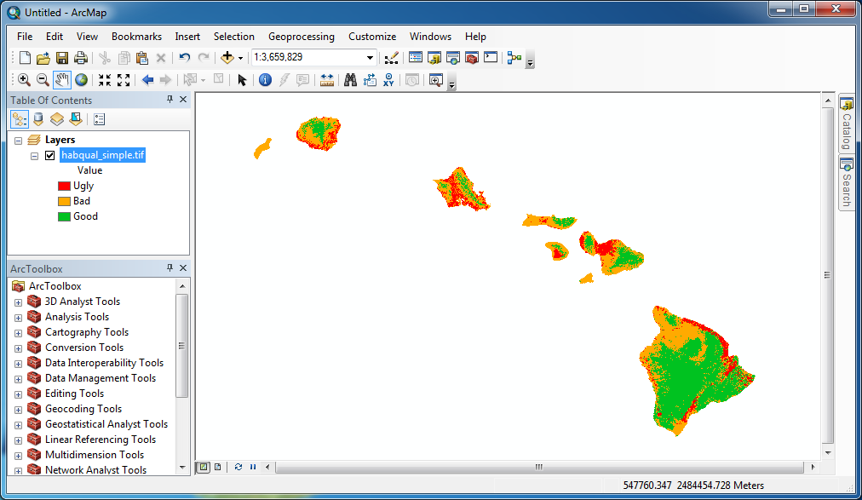

Zoom to the extent of the layer. Maximize the ArcMap window to the full screen. Then go to the File menu -> Export Map…

Depending on the original dimensions of the TIFF file, I would set the resolution to **1200 dpi** or **300 dpi**.  
(WARNING: This is an annoying part of this process – the width and height of the image is dependent on your screen size and cannot be set manually. Only the resolution can be modified. Working with a 1920x1080 monitor, I get roughly 20000x11000 pixels for the export dimensions. You’ll need to adjust the DPI accordingly or accept the difference between output quality.) Also be sure to check the “Write World File” option.

For the Format tab, set the Color Mode to 8-bit. This shouldn’t make much of a difference since we use simple colors. Set the compression to LZW and the background color to pure white.

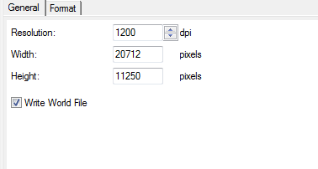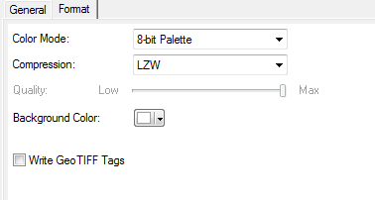

|  |  |  |  |  |
| --- | --- | --- | --- | --- |
| LAYER | Original Dimensions | Color Depth | Output DPI | Output Depth |
| Sea Level | 57333 x 40054 | 8-bit | 1200 | 8-bit |
| Aspect | 5733 x 4005 | 16-bit | 300 | 8-bit |
| Slope | 57333 x 40054 | 8-bit | 1200 | 8-bit |
| Precip Gradient | 2215 x 1571 | 32-bit | 300 | 8-bit |
| Core / Edge | 19274 x 12647 | 2-bit | 1200 | 8-bit |
| Habitat Quality | 19402 x 12647 | 8-bit | 1200 | 8-bit |
| Landscape Invasibility | 2135 x 1509 | 32-bit | 300 | 8-bit |
| Mean Annual Precip | 2215 x 1571 | 32-bit | 300 | 8-bit |
| Lava | 18971 x 12158 | 32-bit | 1200 | 8-bit |
| Protected Areas | 19861 x 11771 | 32-bit | 1200 | 8-bit |

The output DPI was selected based on if the image was “large” or “small”.

### MapTiler – Exporting Tile Hierarchy

With the new exported TIFFs, we can now generate the files/folders using MapTiler. You can download the software from this website: <http://www.maptiler.org/>

Start the program and select the Google Earth (KML Superoverlay) option.

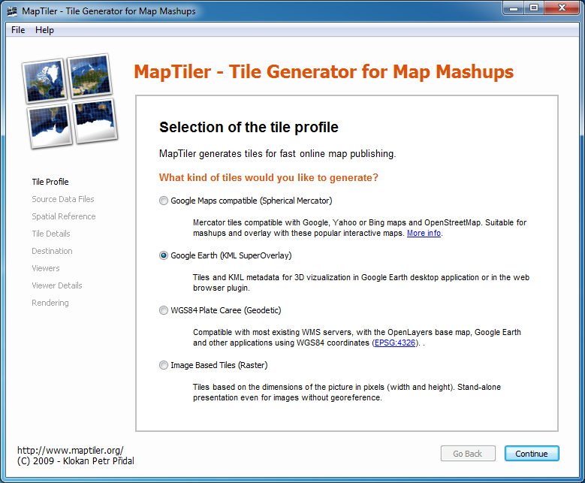

Add a single TIFF image to the input list. (There should be no need to modify any georeferencing option.) Set the transparency color to pure white (to match the export setting we used earlier.)

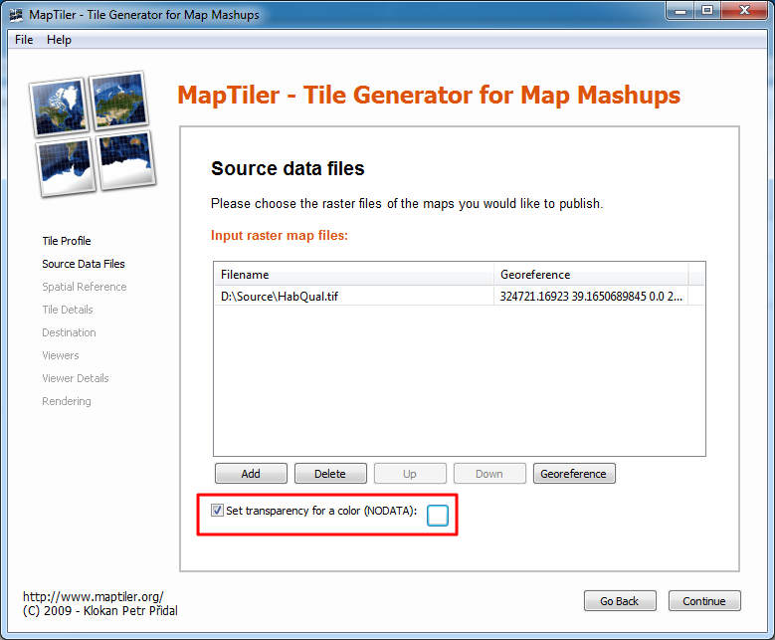

Change the drop down selection to **“Specify the id-number from the EPSG/ESRI database.”** Change the EPSG value to **26904** to match the projection of the data. This will be the same for all the TIFFs since we know the source data’s projection. If the data you are using has a different projection, you’ll need to use the EPSG Registry link provided or go to a site like: <http://www.spatialreference.org/> (my preference) to find the proper code. After you enter the code, click on the **Set** button.

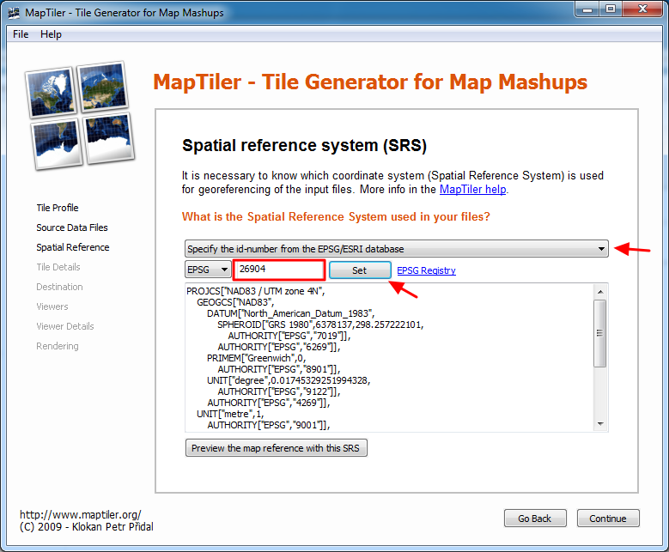

For the tile settings, the defaults were used. The maximum zoom level will change depending on the dimensions of the input TIFF size. The larger the image, more levels will be created. You can add more if desired. The Hybrid JPEG+PNG for Google Earth option is also suitable. (Not sure if it’s a bug, but this option can’t be changed anyway.)

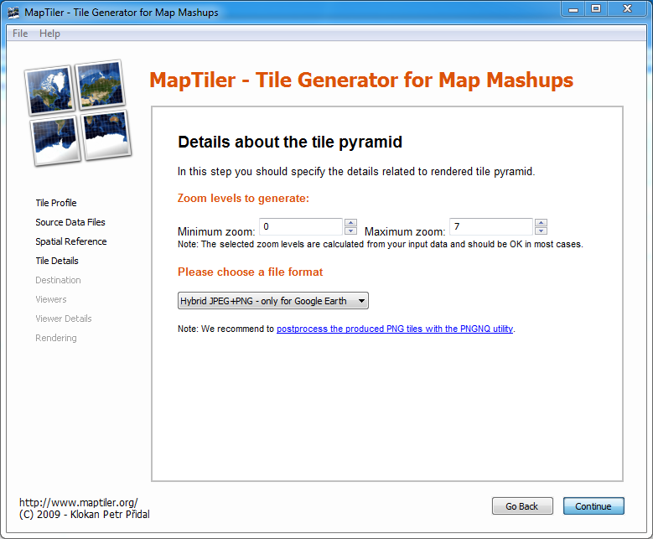

Set a result directory if desired. (Also not sure if it’s a bug, but I’ve tried changing this and it still outputs to the default set here.) Ignore the Destination URL setting, we won’t be using this.

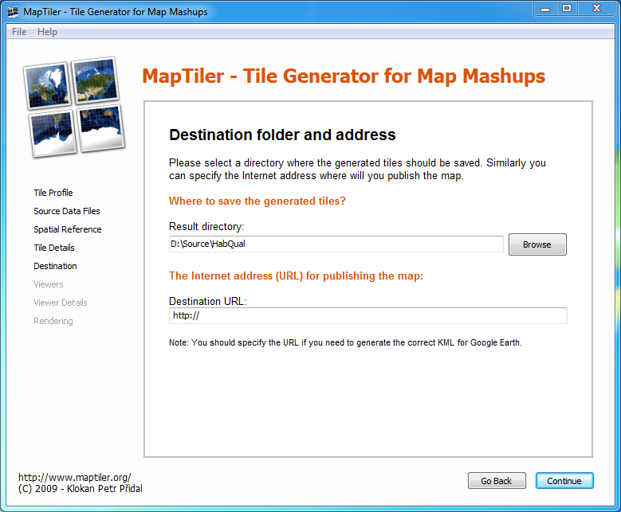

Leave the **Google Earth (KML SuperOverlay)** option selected.

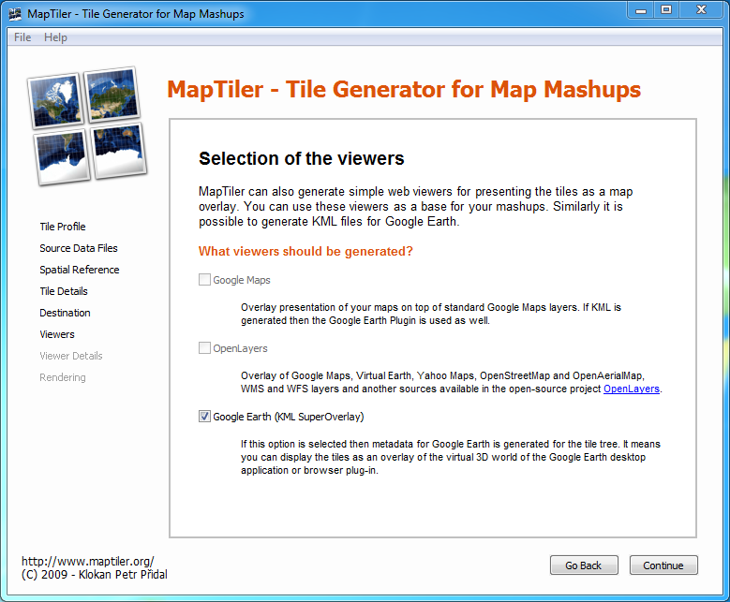

Change the Title of the map. This will be the name of the layer that appears in the table of contents in Google Earth. Remove the copyright notice text.

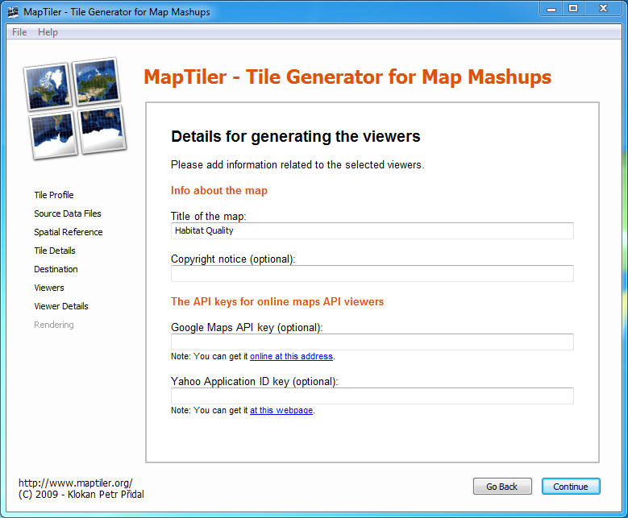

Click **Render** to generate the files.

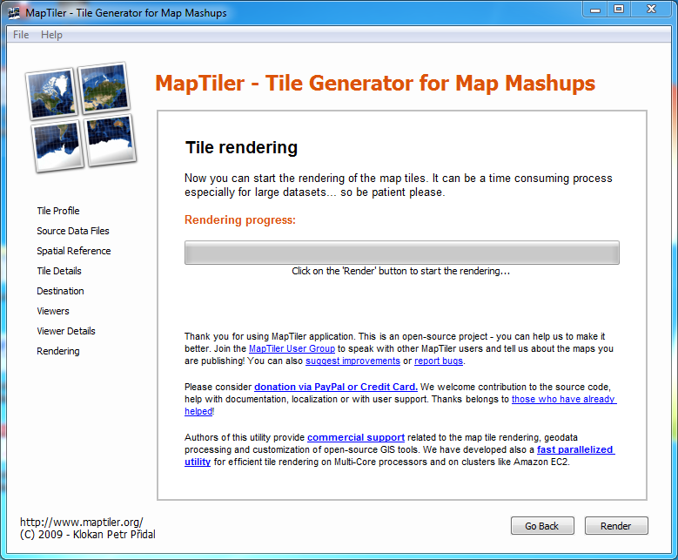

For the output folder of each TIFF processed, there should be a doc.kml generated. This needs to edited to properly reference the tiles that we intend to zip up using the exportkml script. Two tags need to changed, the <name> and <href> tags shown in the screenshot below. You need to add **Maptiles/(foldername)/** to the beginning of each link. This is to ensure proper relative paths. Substitute foldername with the exact name of the output folder that holds each doc.kml. Repeat this for all the rendered superoverlays. Copy all these folders to the **Maptiles** folder for inclusion in the output of the exportkml script. (Currently the Maptiles folder is located in the Dropbox/map data folder.)

